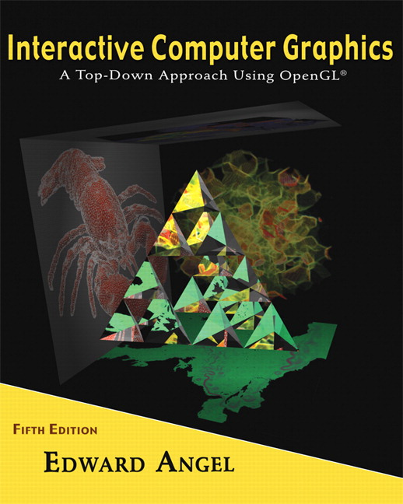

Name: ______________________ Terminal # ____

Programming Assignment 1
(100 points)

The Programming Assignment is to be turned in the first ten minutes of the due date class as:

Hardcopy (with your terminal #!)
Source Code and Vertices Blue Print and Screenshots that shows that your Visual Studio 2010 “Programming Assignment 1” PROJECT compiles and runs!

Electronic: Submit the Visual Studio2010 “Programming Assignment 1” zipped PROJECT to BB so you can run it in 200 PGH!

S’COOL BUS - Summer 2012 Modeling Instructions

1. The glutCreateWindow OpenGL call will take as parameter “YourLastName BUS Version 1”.
2. The file “S’COOL BUS Summer 2012.pdf” contains the specifications for the BUS that you will start modeling in this first programming assignment.
3. In the “void myReshape(int w, int h)” function, you need to adjust the viewing box to allow “glOrtho” to contain the parts of your BUS.

Get a screenshot of the “YourLastName BUS Version 1” window.

4. Adjust the camera so you can get the Front image of BUS (gluLookAt added to display function).

Get a screenshot of the “YourLastName BUS Version 1” window.

5. Adjust the camera so you can get the Back image of BUS (gluLookAt added to display function).

Get a screenshot of the “YourLastName BUS Version 1” window.

6. Adjust the camera so you can get the Side image of BUS (gluLookAt added to display function).

Get a screenshot of the “YourLastName BUS Version 1” window.

7. Adjust the camera so you can get the Isometric image of BUS (gluLookAt added to display function). This means that camera needs to be placed on the line from (0,0,0) to (1,1,1), aiming at the BUS origin (0,0,0) and the up vector is on the y axis (0,1,0) (see Homework 2, part 8, page 30).

Get a screenshot of the “YourLastName BUS Version 1” window.

